Data Type
- Integer
- String
- Date
- Date and Time
- Boolean (True, False)
- Geograpy

Two category in Tableay
- Definition: Dimensions are categorical fields
- Definition: Measures are quantitative fields

Drill Down and Harerchies:
Creating sub category under a Category
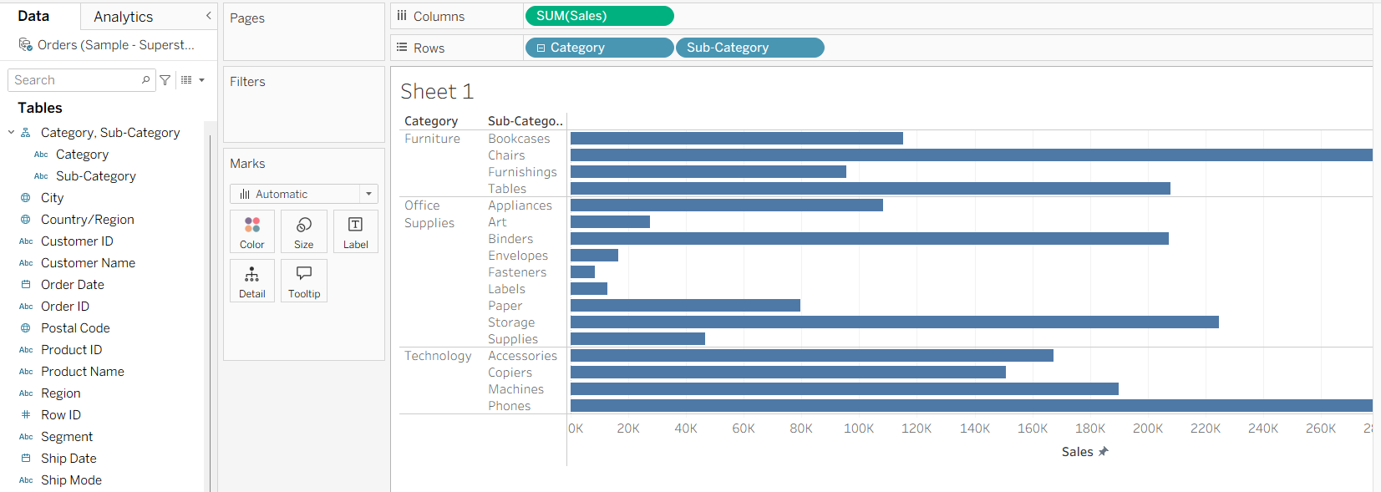

For dates: there is default Drill down and Harerchies:

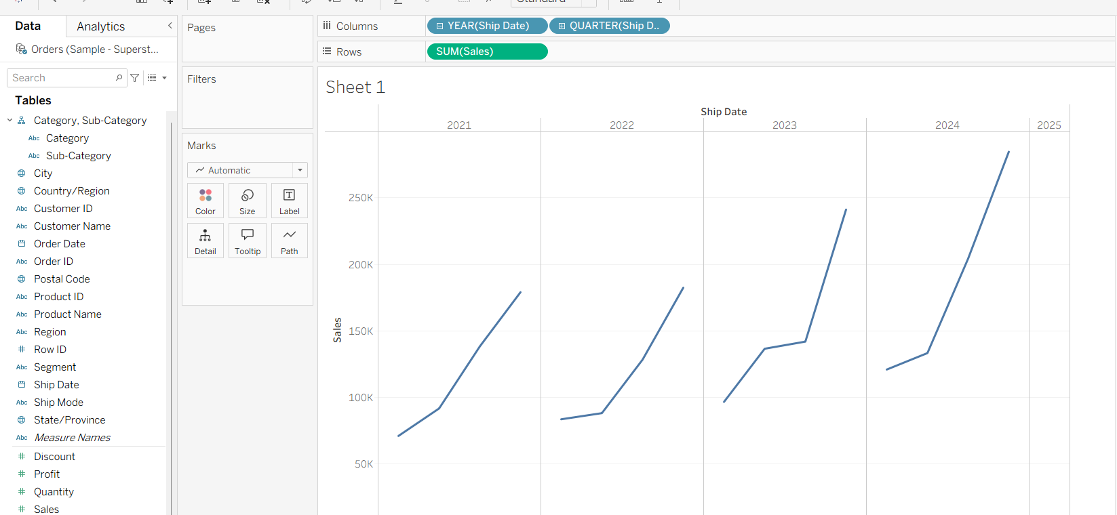

Grouping:

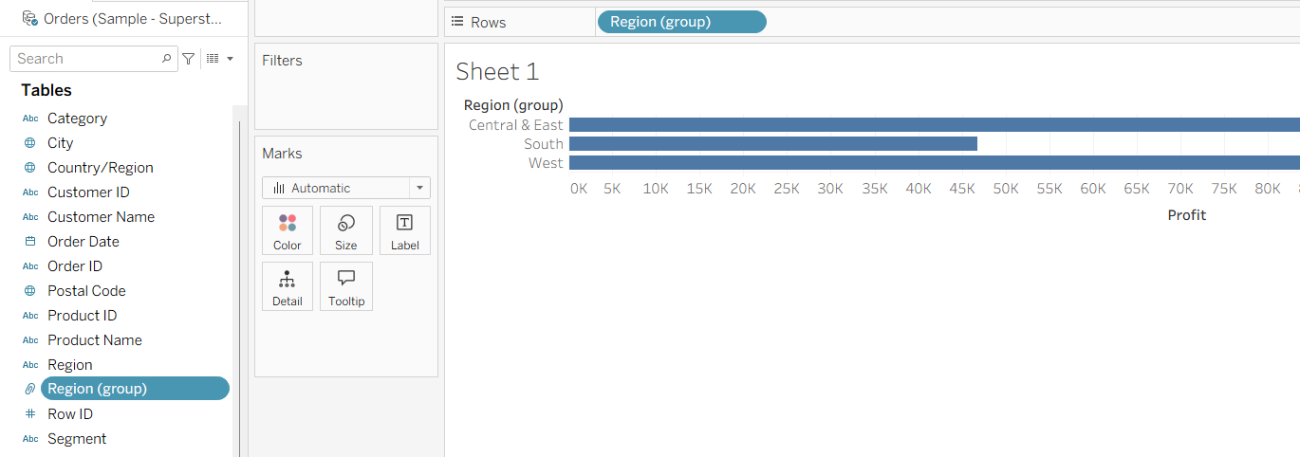

Measure Names and Values:
- Measure Names
- Longitude
- Latitude
- Numer of Records
- Measure Values

Parameters:

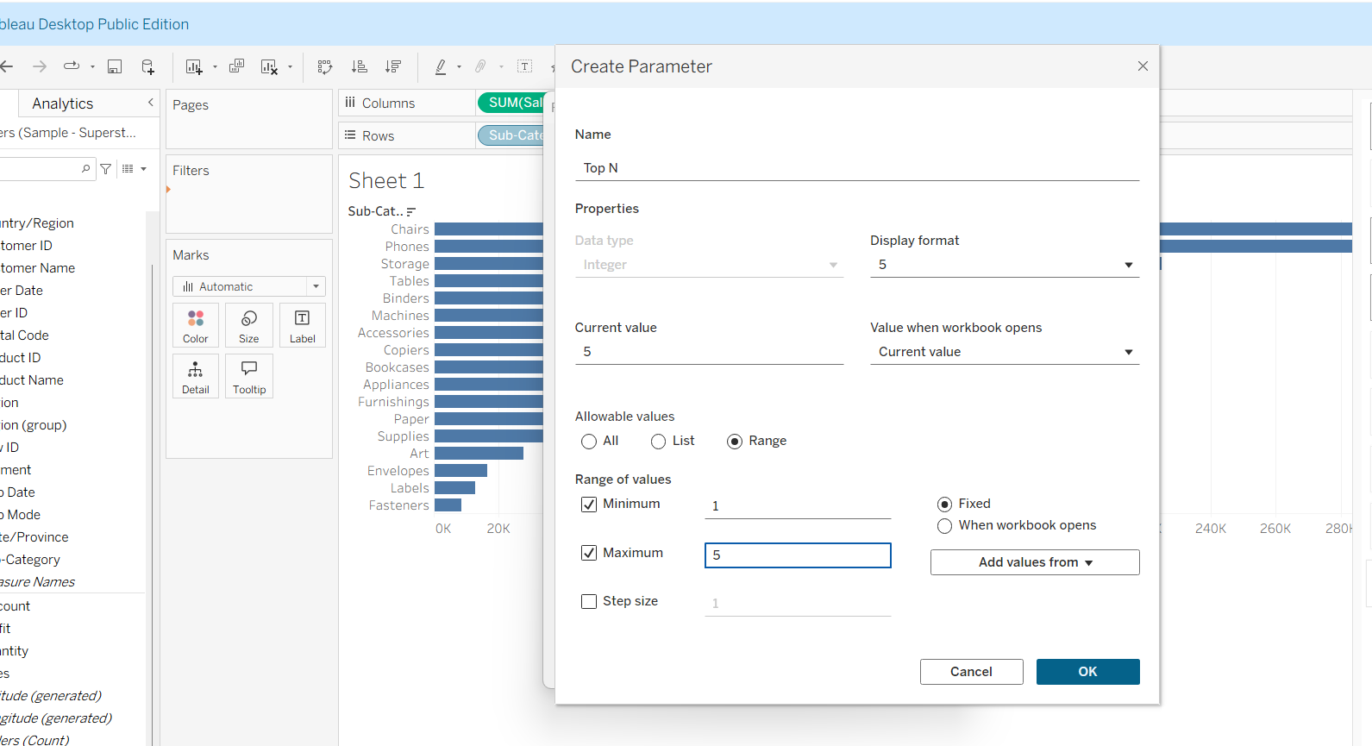

Data Type
- Integer
- String
- Date
- Date and Time
- Boolean(True, False)
- Geograpy
